White Paper: Establishing a Centralized AI Governance Program with a Federated Execution Approach

Table of Contents
- Executive Summary
- Introduction
- Fostering AI Literacy and a Common Language
- Why AI Governance Matters
- AI Initiative Intake: Building a Central Idea Inventory
- Evaluating AI Ideas: Value, Cost, and Feasibility
- Executing a Structured AI PDLC
- Observation and Monitoring: Safeguarding AI Integrity
- Ensuring Compliant Procurement and Technology Alignment
- Applying the Three Lines of Defense
- Clarifying Roles and Responsibilities: A RACI Matrix Aligned with the Three Lines of Defense
- Conclusion
- Appendix

1. Executive Summary

KPMG partners with organizations to design and embed an AI Governance Program that balances rigorous oversight with the freedom for individual business units to innovate. Our approach begins by raising AI literacy to establish a shared understanding of terminology and potential capabilities across the organization. We then develop a central governance framework to align on policies and risk parameters, while allowing each business unit to adapt execution to local needs.

Through this combination of centralized policy and federated execution, our clients maintain consistent standards, regulatory compliance, and risk management without stifling innovation. Every step is guided by a structured assessment framework, robust Software Development Lifecycle (PDLC), and continual monitoring, all underpinned by a three-lines-of-defense model to clarify roles and responsibilities. Additionally, we formalize these responsibilities with a RACI matrix, enabling effective collaboration and accountability at scale.

2. Introduction

Organizations across industries strive to harness AI's potential for personalization, anomaly detection, and predictive analytics—while grappling with strict regulatory obligations and customer expectations around fairness, privacy, and data security. KPMG addresses these challenges by helping clients define an enterprise-wide AI Governance Program that ensures consistent standards, responsible decision-making, and transparent accountability.
This white paper details how KPMG's methodology enables organizations to:

- Establish a single, central definition of AI governance guidelines that enforce compliance and risk thresholds.
- Allow federated teams to innovate with AI solutions tailored to their specific markets or functional areas.
- Implement a foundation of AI literacy so that all stakeholders speak a consistent language and collaborate effectively on AI concepts.

3. Fostering AI Literacy and a Common Language

A key to successful AI governance is ensuring the entire organization shares a baseline understanding of AI's potential, risks, and ethical considerations. KPMG helps clients by:

- AI Training and Workshops
  - We create customized training programs that demystify AI concepts—such as machine learning, data modeling, or ethical considerations—tailoring the curriculum to different skill levels.
- Terminology Alignment
  - We ensure the same definitions and vocabulary are used across all business units (e.g., "data drift," "model bias"), preventing confusion and streamlining cross-functional dialogue.
- Role-Specific Insights
  - Our approach includes tailored guidance for critical roles (e.g., data scientists, compliance officers, front-line managers) so that each team member knows how AI applies to their domain.
- Ongoing Communication Framework
  - We help establish channels—such as internal discussion forums or a governance portal—so business units can share successes, collaborate, and maintain consistent AI standards.

By fostering a common language, we empower diverse teams to collaborate effectively on AI initiatives, accelerating adoption and minimizing misunderstandings around capabilities, risks, and responsibilities.

4. Why AI Governance Matters

When executed responsibly, AI becomes a powerful lever for cost savings, improved customer experience, and strategic decision-making. However, organizations must also navigate a complex matrix of regulations and ethical considerations. KPMG helps clients understand that robust AI governance supports:

- Centralization for Cohesion
  - We define an enterprise-wide governance structure that ensures consistent standards and eases regulatory compliance across multiple business units.
- Federated Execution for Flexibility
  - We guide local teams so they can customize AI solutions for their customers' needs and market conditions while still respecting overarching governance rules.
- Regulatory Alignment
  - Our frameworks incorporate privacy regulations, anti-discrimination guidelines, and industry best practices, setting clear guardrails from day one.
- Risk Mitigation
  - We facilitate early risk identification—covering everything from operational exposure to ethical concerns—so that organizations can proactively address and mitigate threats.
- Innovation Enablement
  - By clarifying compliance and risk parameters at the outset, teams can focus on creativity and speed in AI development, trusting they are moving within safe boundaries.

5. AI Initiative Intake: Building a Central Idea Inventory

Our support begins with establishing a centralized inventory of AI ideas, ensuring visibility and coordinated prioritization across the enterprise:
- Open Channels for Submission
  - We design intake processes and digital portals that encourage diverse teams to share AI concepts—ranging from back-office efficiency to novel customer-facing products.
- Standardized Intake Forms
  - Through forms and documentation templates, we capture critical details, such as data requirements and business goals, enabling uniform evaluation of all ideas.
- Governance Committee Review
  - KPMG works with a cross-functional panel (risk, compliance, technology, and business) to rapidly assess the feasibility, alignment, and potential impact of each proposal.
- Federated Execution
  - Once an idea is approved at the central level, local teams develop and own the solution, while adhering to enterprise governance standards and AI literacy principles established upfront.

6. Evaluating AI Ideas: Value, Cost, and Feasibility

We provide a comprehensive assessment framework to help clients validate which AI initiatives merit investment and align with enterprise goals:

- Value Proposition
  - Financial Benefits: We calculate potential ROI, efficiency gains, or revenue lift.
  - Strategic Alignment: We confirm initiatives reinforce the organization's brand positioning and expansion strategy.
- Cost and Resource Analysis
  - Budgeting: We include licensing fees, cloud costs, training overhead, and ongoing maintenance in cost models.
  - Organizational Readiness: We assess skill gaps, training needs, and capacity constraints to ensure local teams are prepared to absorb new AI solutions.
- Risk and Complexity
  - Regulatory Considerations: We evaluate for compliance with consumer protection, privacy, and anti-discrimination laws.
  - Technical Dependencies: We identify any data pipelines, vendor tools, or existing processes that must be integrated or upgraded.

By ensuring only the most impactful and compliant ideas progress, clients can confidently allocate resources and leadership support.

7. Executing a Structured AI PDLC

Once validated, we help clients guide AI solutions through a disciplined Software Development Lifecycle (PDLC):

- Planning and Requirements
  - KPIs and Metrics: We define success metrics early (e.g., accuracy, customer satisfaction).
  - Security and Compliance: We embed data privacy, encryption, and user-access controls from the start.
- Design and Development
  - Federated Approach: While business units customize the solution, we ensure they incorporate central guidelines on data handling, coding standards, and documentation.
  - Version Control: We set up best practices for logging model changes, training sets, and parameter tuning.
- Testing and Validation
  - Performance and Stress Testing: We establish how solutions behave under peak or varied conditions.
  - Bias and Fairness Assessment: We help teams identify, track, and mitigate potential bias or disparate impacts in AI outputs.
- Deployment and Integration
  - Phased Rollouts: We encourage controlled deployments, letting teams gather feedback and fine-tune before full-scale launches.
  - Human-in-the-Loop: Where legally or operationally required, we help retain human oversight for critical decision points.
- Maintenance and Evolution
  - Continuous Monitoring: We supply tools and processes to detect data drift, performance degradation, and emerging regulatory issues.
  - Retraining Cycles: We establish protocols for retraining models to match changing market conditions or data quality improvements.

8. Observation and Monitoring: Safeguarding AI Integrity

Sustained oversight enables clients to stay ahead of risks, maintain compliance, and ensure models deliver consistent results:

- Automated Monitoring
  - Metric Dashboards: We configure dashboards displaying real-time accuracy, throughput, error rates, and resource usage.
  - Anomaly Detection: Automated triggers alert relevant teams when data patterns shift unexpectedly.
- Governance Dashboards
  - Enterprise Visibility: Senior leaders can quickly scan the health of all AI initiatives, identifying bottlenecks or risk flags.
  - Local Alignment: Federated business units can add their own tailored performance indicators for more granular oversight.
- Regular Audits
  - Internal Checkpoints: We help schedule audits to verify ongoing alignment with policies.
  - External Reviews: Where necessary, we recommend external specialists to validate fairness or security in more complex AI systems.

9. Ensuring Compliant Procurement and Technology Alignment

We recognize that many organizations leverage third-party solutions to augment or expedite AI capabilities. KPMG helps:
- Vendor Risk Assessment
  - Security and Privacy: We confirm the vendor's protocols for handling sensitive data align with industry regulations and client standards.
  - Model Transparency: We require vendors to provide insights into their models' training data, architecture, and interpretability features.
- Procurement Best Practices
  - Federated Model: We enable different business units to select specialized solutions, provided they meet established central governance criteria.
  - Contractual Safeguards: We help define service-level agreements, data ownership terms, and liability clauses for non-compliance or poor performance.
- Integration with Central Standards
  - Consistency: We ensure vendors satisfy the same rigors we apply internally, from data lineage tracking to model auditability.

10. Applying the Three Lines of Defense

A robust AI governance model relies on a structured, tiered approach to risk management and oversight. KPMG incorporates the three lines of defense by:

- First Line (Frontline Business Teams)
  - Day-to-Day Ownership: Local teams build, deploy, and maintain their AI solutions under enterprise guidelines.
  - Issue Identification: They flag anomalies, performance shortfalls, or potential risk triggers to the second line for deeper investigation.
- Second Line (Risk Management and Compliance)
  - Policy Setting: We help this layer design frameworks that dictate acceptable risk thresholds and compliance protocols.
  - Monitoring and Advisory: They offer continuous guidance and review to first-line teams, stepping in to address escalated concerns.
- Third Line (Internal Audit)
  - Independent Assurance: We work closely with internal audit teams to provide them with the documentation and insights needed to confirm that first- and second-line efforts remain effective and consistent.
  - Recommendations: Auditors offer targeted process refinements and governance enhancements, ensuring long-term resilience.

11. A RACI Matrix Aligned Three Lines of Defense

To avoid confusion and empower collaboration, KPMG creates a RACI matrix that directly reflects the three lines of defense:

- First Line (Frontline Business Teams)
  - Responsible (R): Operational owners of AI tasks—e.g., data ingestion, model building, day-to-day execution.
  - Dependent Relationship: They rely on timely support from second-line experts and transparent audits from the third line.
- Second Line (Risk Management and Compliance)
  - Consulted (C): They advise on policy and legal implications throughout the AI lifecycle.
  - Dependent Relationship: They need continuous updates from the first line to track compliance and risk metrics, collaborating with internal audit to resolve gaps.
- Third Line (Internal Audit)
  - Accountable (A) or Informed (I): Audit teams ultimately verify that each defense layer is functioning as intended. In some scenarios, they may be primarily informed but hold final accountability for governance efficacy.
  - Dependent Relationship: Accurate and consistent documentation from both first and second lines is key to successful audits and meaningful recommendations.
- Cross-Functional Dependencies and Communication
  - We help establish communication pathways so that each line can efficiently share information, escalate concerns, and realign activities with corporate governance standards.
  - We periodically refine the RACI matrix to reflect any organizational changes or evolving regulatory requirements, ensuring all stakeholders remain fully aware of their roles.

12. Conclusion

KPMG's end-to-end methodology assists clients in designing and implementing a centralized AI governance framework that supports federated execution. By first building AI literacy, we ensure a shared language and understanding across the enterprise, enabling informed collaboration. We then guide clients in creating processes for idea intake, feasibility assessment, PDLC structuring, and procurement governance.

Through continuous monitoring, a three-lines-of-defense model, and a RACI matrix aligned with each line's responsibilities, organizations can balance robust compliance with agile innovation. Our approach ensures that emerging AI initiatives are developed under consistent policies, quickly adopted by local teams, and rigorously assessed for risk, thereby maximizing returns without compromising on trust or integrity.

Appendix:

Enhancing AI Governance Through Business Process Management Solutions

In this white paper, we discuss how we help our clients establish the foundational elements of an AI governance program. While this framework provides significant value, we also recommend clients implement these processes through technology-enabled Business Process Management (BPM) solutions to ensure sustainable deployment of approved methodologies across the organization.

BPM solutions transcend static diagrams by offering executable frameworks where centrally defined governance structures can be instantiated as models that federated organizations can readily implement. This implementation becomes a straightforward process of following step-by-step approaches defined in the approved BPM processes, ensuring that distributed teams making AI decisions adhere to established guidelines embedded within these models. Additionally, these solutions can be configured to automatically escalate compliance violations, enabling proactive risk mitigation.

Consider our model that defines the AI initiative intake process, designed to help clients systematically manage the diverse portfolio of AI ideas and initiatives that proliferate across organizations. This model structures both the initial capture of proposed AI concepts and the subsequent quantitative assessment protocol. Through comprehensive risk evaluation and capability assessment, it provides a clear determination of the organization's readiness to successfully execute implementation. By embedding these standardized workflows in Business Process Management solutions, organizations maintain consistent governance standards while preserving the flexibility necessary for different business units to adapt to their unique operating environments and requirements. This approach ensures that innovation thrives within appropriate risk parameters, allowing federated teams to pursue AI opportunities with clearly defined guardrails.

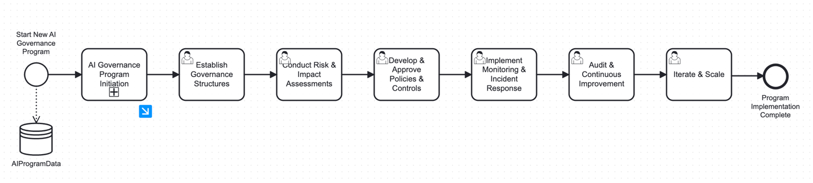
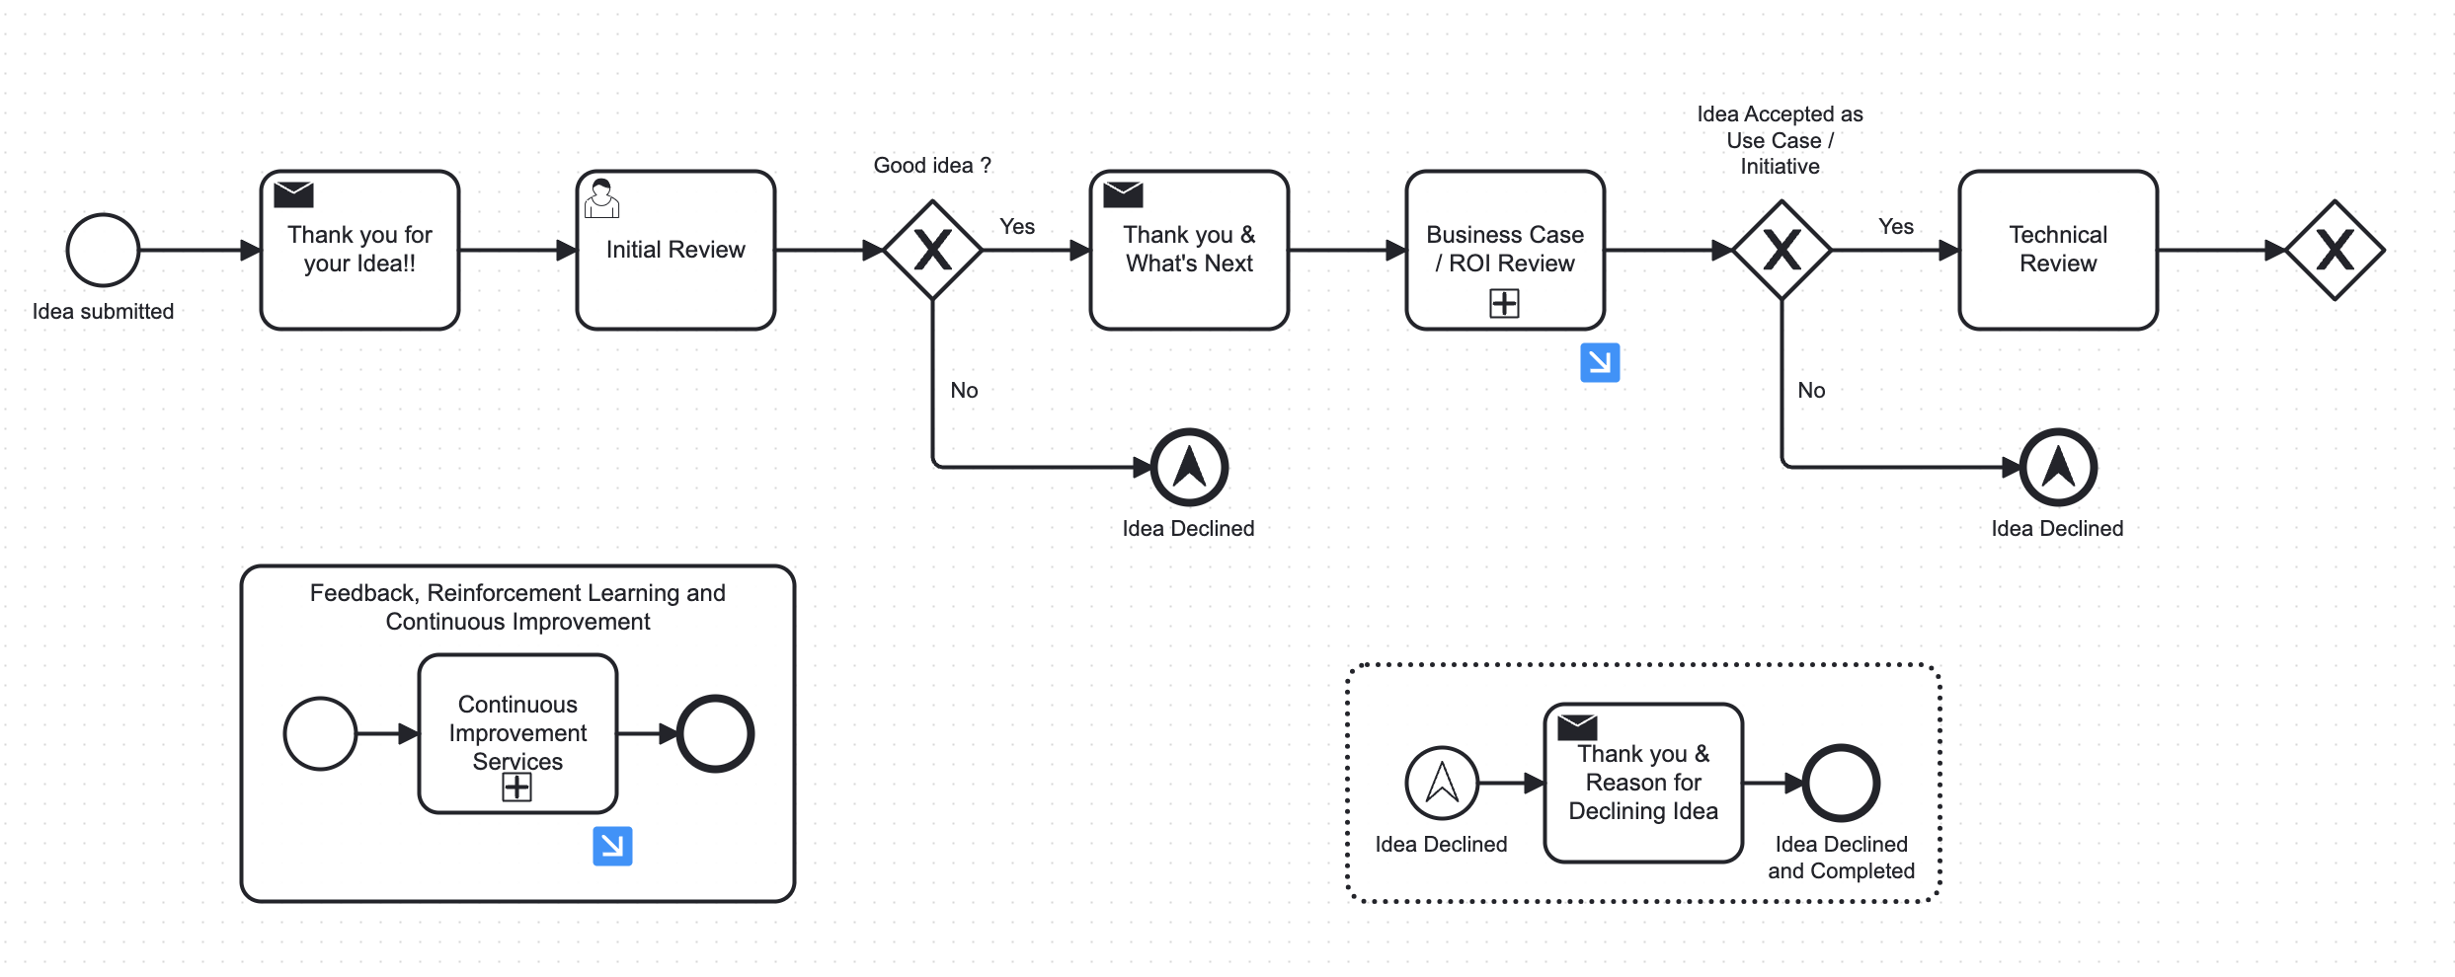

The integration of BPM technology with our AI governance framework creates a dynamic system that not only documents but actively enforces governance standards, providing real-time visibility into compliance and streamlining decision-making processes across the enterprise.

